|  |  |
| --- | --- |
| VHT2 Tips |  |

**Part A1a and A2a – Assigning attributes to the correct tables during move from 1NF to 2NF and 2NF to 3NF**

Here is the [normalization case study](https://srm--c.na13.visual.force.com/apex/coursearticle?Id=kA0a0000000PKmsCAG) which will help with Part A (1 and 2). It provides an excellent example of the normalization process (moving data from unnormalized through 3NF) and utilizes a data scenario similar to the one you’ll see on the performance assessment.

If you would like to look at a second resource, reviewing [*The Data Normalization Process* section](https://wgu.vitalsource.com/reader/books/9781118293102/epubcfi/6/18%5bidloc_008.xhtml-itemref%5d!/4%5beid14565%5d/16%5beid16136%5d/2%5beid16137%5d/2%5beid16138%5d/1:28%5bOCE%2CSS%5d) in Chapter 7 of the supplement eBook – *Fundamentals of Database Management Systems* by Mark L. Gillenson will also be helpful.

[VHT2 Normalization and Relationships Recording](https://wgu.hosted.panopto.com/Panopto/Pages/Viewer.aspx?id=6f89341e-ad4c-48c7-b836-adff017c1834) – Walks through normalization of a dataset from unnormalized to 3NF

**Parts A1b and A2d** (cardinalities in dotted cells) and Descriptions of the relationship/cardinality between the tables

Reviewing one or both of these resources may be helpful:

* [Entity Relationships Recording](https://wgu.hosted.panopto.com/Panopto/Pages/Viewer.aspx?id=6f89341e-ad4c-48c7-b836-adff017c1834) – Overview of different types of relationships
* zyBooks Lesson 5, Section 5.7
* [Data Modeling](https://wgu.vitalsource.com/reader/books/9781118293102/epubcfi/6/8%5bidloc_003.xhtml-itemref%5d!/4%5beid866%5d) in Chapter 2 of the supplement eBook – *Fundamentals of Database Management Systems* by Mark L. Gillenson.

**A1b and A2d *–* Descriptions of the relationship/cardinality between the tables**

For this aspect, you’ll need to include a statement that explains the relationship in both directions (e.g. – A patient schedules a maximum of many appointments. An appointment is linked to a maximum of one patient.

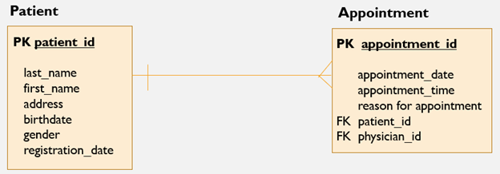

Again this video will be helpful:

[Entity Relationships Recording](https://wgu.hosted.panopto.com/Panopto/Pages/Viewer.aspx?id=6f89341e-ad4c-48c7-b836-adff017c1834) – Overview of different types of relationships

**A1c and A2e - Explanations of how you assigned attributes to the tables**:

For the explanations for Part A (Normalization), Evaluation will be looking to see that you understand what is happening at each stage. These explanations should demonstrate your understanding of the normalization process. You will want to describe what you did to move the data into the next form (From 1NF to 2NF, and 2NF to 3NF). The best thing to do is to have the definitions of 2NF – 3NF handy as you draft these explanations.

1NF – A primary key that provides a unique value for all records is established, each attribute in the table is represented by an atomic value, and there are no repeating groups.

2NF – Each table is 1NF compliant and all attributes that are not part of the primary key are completely functionally dependent on the entire primary key.

3NF – Each table is 2NF compliant and no attributes that are not part of the primary key are transitively dependent on other attributes that are also not part of the primary key.

Here is an example for moving from Unnormalized to 1NF:

1NF – When moving to 1NF, the repeating groups problem was resolved by storing the information for each activity in its own record. a composite primary key (registration_id and activity_id) was assigned to provide a unique value for all records in the table. The volunteer’s address was broken into separate fields to ensure that all fields contained atomic values.

Again, the [normalization case study](https://srm--c.na13.visual.force.com/apex/coursearticle?Id=kA0a0000000PKmsCAG) may be helpful when writing your explanations.

**Part A3b**You can find a list of Common MySQL data types in zyBooks Lesson 2, Section 2.3. These resources may also be helpful:  
These resources may also be helpful:

[Data Types](https://dev.mysql.com/doc/refman/8.0/en/data-types.html) from MySQL.com  
[MySQL Data Types](https://www.w3schools.com/sql/sql_datatypes.asp) from w3schools.com

NUMERIC DATA TYPE

|  |  |  |
| --- | --- | --- |
| numeric(p,s) | Fixed precision and scale numbers.  The p parameter indicates the maximum total number of digits that can be stored (both to the left and to the right of the decimal point). p must be a value from 1 to 38. Default is 18.  The s parameter indicates the maximum number of digits stored to the right of the decimal point. s must be a value from 0 to p. Default value is 0 | 5-17 bytes |

**Part B Tip – Best way to show your SQL statements and that they executed successfully:** Evaluation needs to see each statement in the window along with proof that the statement executed successfully. You can include more than one statement in a screenshot (e.g. - including all CREATE TABLE statements in one screenshot), but keep in mind that Evaluation must see every statement with indication that the statement executed successfully. Please try to avoid multiple screenshots including the same SQL statement as this makes it difficult for Evaluation to review the task.

CREATE TABLE volunteer

(

volunteer_id int NOT NULL,

last_name varchar (20) NOT NULL,

first_name varchar (20) NOT NULL,

street_address varchar (20) NOT NULL,

city varchar (20) NOT NULL,

state varchar (20) NOT NULL,

zip_code varchar (7) NOT NULL,

phone_number varchar (14) NOT NULL,

email varchar (30),

PRIMARY KEY (volunteer_id)

);

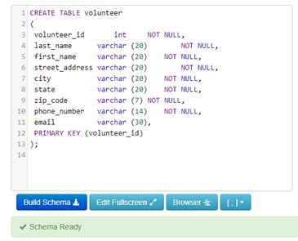

**Example with multiple statements in one screenshot**

CREATE TABLE volunteer (

volunteer_id int NOT NULL,

last_name varchar (20) NOT NULL,

first_name varchar (20) NOT NULL,

phone_number varchar (14) NOT NULL,

email varchar (30),

PRIMARY KEY (volunteer_id)

);

CREATE TABLE coordinator (

coordinator_id INT NOT NULL,

coordinator_last_name varchar(20) NOT NULL,

coordinator_first_name varchar(15) NOT NULL,

coordinator_phone varchar(14),

PRIMARY KEY (coordinator_id)

);

CREATE TABLE activity (

activity_id int NOT NULL,

activity_name varchar(30) NOT NULL,

activity_date date NOT NULL,

coordinator_id int NOT NULL,

PRIMARY KEY (activity_id),

FOREIGN KEY (coordinator_id) REFERENCES coordinator (coordinator_id)

);

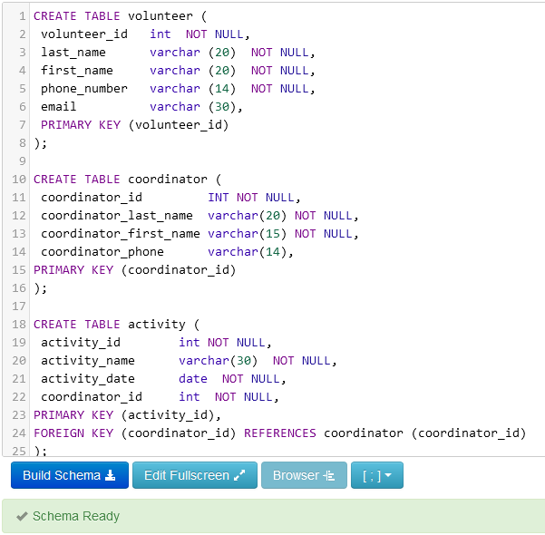

**Part B**   
This resource will be helpful with Part B:

[MySQL Helps/Information](https://srm--c.na13.visual.force.com/apex/coursearticle?Id=kA0a0000000PKmnCAG)

[CREATE TABLE](https://www.mysqltutorial.org/mysql-create-table/)[Primary Key](https://www.mysqltutorial.org/mysql-primary-key/)

[Foreign Key](https://www.mysqltutorial.org/mysql-foreign-key/)

[INSERT](https://www.mysqltutorial.org/mysql-insert-statement.aspx)

[INNER JOIN](https://www.mysqltutorial.org/mysql-inner-join.aspx)

[If you run into foreign key constraint errors](https://westerngovernorsuniversity-my.sharepoint.com/:w:/g/personal/maria_schenk_wgu_edu/ESuRyafc-mdNiwnH-ErOqoQBfoC9vcl6lOIBiGewiJaUbQ?e=dZb8lz)

**Part B3a** – CREATE VIEW – Make sure to pull ALL values from the Employee table. Concatenate the first and last name.

[CREATE VIEW Resource](https://www.mysqltutorial.org/create-sql-views-mysql.aspx)

[Concatenate Resource](https://www.mysqltutorial.org/sql-concat-in-mysql.aspx)

**Part B6a** – JOIN query

Here is a recording where the complex join is explained. The join is discussed near the end of the recording (approximately 6 minutes, 15 seconds). I’ve also included a couple of other resources you may find helpful.

[Understanding Joins](https://www.linkedin.com/learning/sql-essential-training-3/understanding-join?u=2045532)

[Accessing Related Tables](https://www.linkedin.com/learning/sql-essential-training-3/accessing-related-tables?u=2045532) in a Join

[Joining multiple tables](https://www.linkedin.com/learning/sql-essential-training-3/relating-multiple-tables?u=2045532)

**Part C** – Please make sure to submit only 1 PDF document. You can place all of the parts of your project into a Word document and then click File > Save As > PDF.